 | 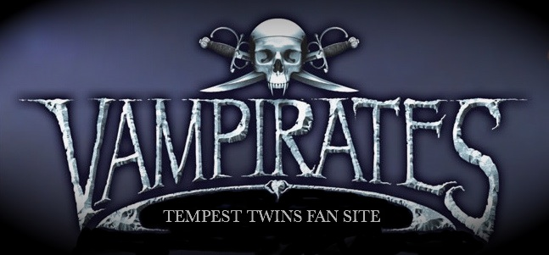
Home  News  Next Book Ideas  What's In A Name  Justin Somper  Lookalikes  Dirty Dolphin  Vampirates  The Nocturn  Book Reviews  Pirate Websites  Who Am I ?  Our Crew  Squeak | What's In A Name?vhjgyg ybtuybtguybfdddtrdtctcxrxre  Bartholomew Pearcebvtfccrtcnyvtfcrtcxbrbrxbrxrbcxntcvtyvtvnvt  Connor's pirate friend also known as Bart, one of the three Buccaneers. He has a soft spot for Cutlass Cate  Bartholomew (bar THOL o myu) is Greek/Hebrew and means son of Tolmai or Talmay. Talmay is a Hebrew name meaning "furrowed".  Cutlass Cate  She thinks before she fights and is a master of weaponry. When Cheng Li leaves the Diablo she is very pleased to become second in command. She has a soft spot for Bart.  Cate (kayt) is English and comes from Katherine which is the name of the woman who Petruchio marries and tries to tame in Shakespeare's comedy 'The Taming of the Shrew'. In Greek it means Pure.

